Cuyahoga National Park

Established in 1974

Wetland Monitoring
The National Park Service has documented over 1,500 wetlands at Cuyahoga Valley National Park. Non-native invasive plant species and pollution are identified as the major management issues for the park.
Wetlands provide numerous ecological services and are important sites of biodiversity, providing habitat for nearly half of all endangered species. As natural floodwater storage sites, wetlands store and assimilate nutrients and reduce stream erosion and storm water-caused flooding. Unfortunately, over half of the wetlands in the United States have been destroyed over the past two centuries. Roughly 90% of wetlands in Ohio have been eliminated.
Human disturbances and invasive plants can alter natural wetland functions. Hydrological changes, such as increased storm water from upstream development or dewatering by drainage ditches and tiles, affect wetland water quality and quantity and often increase pollutant levels. Wetland size, hydrology, and biological composition may change as a result. Disturbances near or within wetlands create susceptibility to the colonization of invasive plant species, which often dominate plant communities.
Heartland Inventory & Monitoring scientists are developing a long term monitoring protocol to document the condition of a subset of wetlands within the park and to track changes in their quality over time. The protocol also includes a watershed-level analysis to evaluate how land use affects wetland condition in specific watersheds. The monitoring data are designed to support park wetland management decisions and restoration efforts.
History
The Cuyahoga River, winding 100 miles through northeast Ohio, offered convenience to growing cities, drawing many people to settle the banks of the once pristine waterway. Growing communities brought industry and companies began using the river as a dumping station for wastes produced by factories. The river quickly fell victim to severe pollution, degrading the water quality and guaranteeing that no life could survive in the thick, murky water. In 1969, a passing rail car created a spark that would ignite more than just a fire on the Cuyahoga River. The fire of 1969 sparked an environmental movement. Just one of over a dozen fires on the Cuyahoga River, the 1969 blaze was nothing new. Industrial rivers, much like the Cuyahoga, burned frequently, but it was the preceding events that made the 1969 fire vastly different from the others. Time magazine published an article about the burning of the Cuyahoga River that would prove to be a pivotal turning point in the fate of the heavily polluted waterway. The "Mistake by the Lake," as the city of Cleveland was called, became a poster child for the environmental movement. Something had to change. The burning of 1969, and subsequent popularity, sparked legislation for the Great Lakes Water Quality Agreement and the Clean Water Act of the early 1970s. The Cuyahoga River, among many others, was on track to cleaner days.
Although much healthier than forty years ago, some sections of the river remain on the list of impaired waters as established under Section 303(d) of the Clean Water Act. Portions of the Cuyahoga River Watershed, including the section of river that travels through Cuyahoga Valley National Park, have been classified as one of the 43 Great Lakes Areas of Concern, necessitating the development of a Remedial Action Plan (RAP).
Longtime residents have witnessed many changes in Cuyahoga Valley, including the resurgence of nature. Steven Moss is one of them. He grew up in Independence, Ohio, with his parents and two younger sisters. He lived on the valley’s northwestern rim from the mid-1950s until 1999. His grandparents had a large house where the national park’s Rockside Station now stands. They immigrated from Mexico when his mother was 3 years old. His grandfather worked for the railroad. Stephen went on to have a career in fisheries management with Ohio Division of Wildlife.
Steven and his mother Josephine Moss recorded oral histories with Cuyahoga Valley National Park in September 2017. Steven’s memories help us better understand how fish and wildlife slowly came back along the Cuyahoga River during the park’s early years.
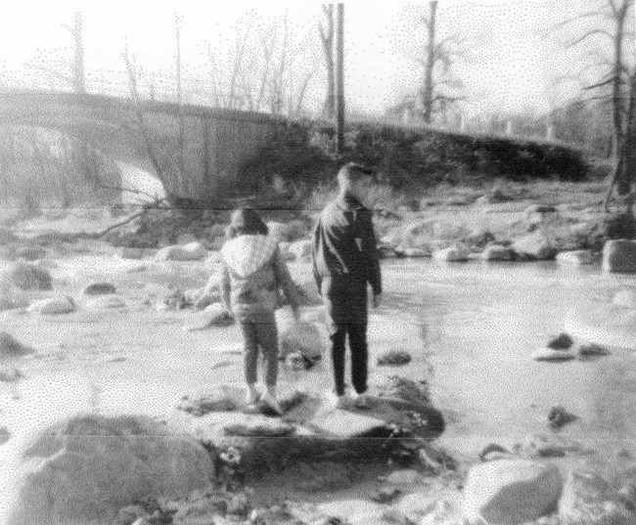Playing in the Cuyahoga near Rockside Road
“During the time I was growing up, Independence [Ohio] didn’t have a lot of new growth or development at all. Very few new houses were built,” Moss recalled. The neighborhood kids would play hide-and-seek, ride their bikes, follow a backyard path into the woods, and catch salamanders and crayfish in a nearby creek. Later, before the national park was created, Steven and his older cousin Allen would hunt rabbit, mallard, and squirrel in the valley for the family stew pot.
His grandparents lived on old Rockside Road where Rockside Station is now. Moss explored the Cuyahoga River near their house: “. . . the banks were kind of steep, but we were able to get on that little sand bar once in a while.” When Steve was very young, his father harvested a truckload of this sand and built a big, square sandbox for the children. Sometimes they’d find tiny shells in it.
His father taught him to fish. “I started out with my dad taking me to one of his friend’s ponds. The first fish I caught was a bullhead. I would always say ‘Dad let’s go fishing, let’s go fishing.’ He and I would take off on weekends and go fishing at various lakes.”
A favorite spot was the Brecksville Diversion Dam near Station Road Bridge. “When I was really little, there was really nothing to fish for in the Cuyahoga River.” He didn’t catch a fish there until his later teens, around 1970-1972. At that time, the river smelled like raw sewage. “Once in a while I would see other people [fishing at the dam], but it would mostly be local kids on bikes down there.” By the mid-to-late 1970s, he remembers seeing them occasionally catch carp, bluegills, and white bass.
As the water quality improved, fishing in the Cuyahoga got better. He caught bluegill, crappie, and rock bass. Eventually he started seeing largemouth and smallmouth bass. By the late 1980s to early 1990s, fish such as pike, gar, and muskellunge started appearing. These need cleaner water. The rarest fish he ever caught was a smallmouth buffalo, which resembles a carp. That was at the dam. He also hooked a nonnative Chinook salmon in about 1986 at the mouth of Tinker’s Creek. This Lake Erie fish was headed upstream to spawn.
“I don’t remember anything like oil slicks. I don’t remember any solid pollutants floating down the stream. It was mostly the foam on the river and along the canal. I remember my dad driving us down along the canal. We would have to sometimes stop the car on Canal Road because these big clouds of soap were blowing across the road. You couldn’t see what was coming the other way, so you had to sit and wait till they blew past before you could keep on going.”
The Kurtz Brothers, a Cleveland landscaping supplier, used to harvest topsoil along the Cuyahoga at the bottom of Pleasant Valley Road. Grass grew up in the depressions left behind. Moss said, “. . . it was a great place for waterfowl . . . I’ve seen hundreds and hundreds of ducks in there at a time during migration. But, as succession goes on, things started growing up and now it’s a lot of trees.” In the 1980s, he would drive down Fitzwater Road where Cuyahoga Valley Scenic Railroad now has its maintenance yard. He would sit and watch as many as 500 Canada geese, mallard, shoveler, and teal fly over and land in the wetland between Fitzwater and Pleasant Valley roads.
“I remember [my] school on Hillside Road. There was a deer actually seen in the field right at the edge of the grass. Everybody—all the classes—went to this one room just to look out the window to see a deer. This was in the early to mid ‘60s . . . it was a big thing to see a deer, period, when I was young. [It wasn’t] until probably the later ‘70s that I started seeing them a little bit more often . . . The number of deer has increased dramatically in the Cuyahoga Valley and it’s not unusual to see deer along the stream while I’m fishing.”
Beaver Marsh
During the fall season, beavers store softwood branches, such as willow and aspen, in front of their lodge as a winter food supply. Look for southbound waterfowl during the fall migration which starts to peak in late October. Sometimes you can spot more than 20 wood ducks within the marsh and surrounding channels.
Starting in the 1800s, land development drained the original wetland. The Ohio & Erie Canal came through. Darwin Carter had a dairy farm on part of the property. Just before the National Park Service purchased the land, an auto repair shop was here, surrounded by old cars and worn-out parts. During the establishment of the park, efforts by humans and beavers transformed this site back into a wetland.
In 1984 the Portage Trail Group of the Sierra Club organized a site clean-up. Together with the National Park Service, they hauled away car parts, bed springs, and accumulated trash. Plans for the property were unresolved; the young park was considering building a parking lot here. Around the same time, beavers started returning to the valley. They had been absent from Ohio for over a century, trapped out for their fur. Beavers built a system of dams that flooded the area. By altering their environment and creating deep water, beavers can enter their lodge underwater and swim to gather building supplies and food, avoiding the dangers of land.
Humans cleaned up and preserved the land. Beavers restored natural water levels, awakening long-dormant seeds in the soil. Wetland plants returned, creating habitat for diverse wildlife.
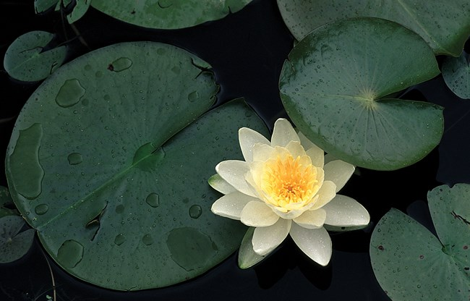Sweet-scented water lilies bloom in summer.
Ohio has lost nearly 90% of its wetlands to development. Nationally, 46% of endangered or threatened species need wetlands. Cuyahoga Valley National Park protects nearly 1,500 individual wetlands covering over 1,900 acres of parkland. Many of these are less than one acre. The 70-acre Beaver Marsh is significant because of its size, rich seed bed, complex water chemistry, and diversity of life.
To measure wetland health, resource managers use the Vegetation Index of Biotic Integrity (VIBI). Scientists found highly sensitive wetland plants such as hairy fruited sedge, skunk cabbage, marsh fern, speckled alder, buttonbush, and sweet-scented water lily. In some degraded areas, invasive plants such as narrow-leaved cattail, common reed, and purple loosestrife are crowding out other species.
The VIBI plant surveys also confirmed that there are several microhabitats within the marshland, supporting distinct plant communities. This mosaic, in turn, supports a greater variety of wildlife.
The Beaver Marsh reminds us of what can happen when natural places are protected and natural processes are allowed to occur. However, we must remain vigilant to threats that could undermine its pristine qualities. As you enjoy the serene beauty and abundant wildlife, consider your role in ensuring that the Beaver Marsh has a bright future.
Native American History
American Indians have lived in Northeast Ohio for 13,000 years. Paleoindians were the earliest people in what is now Ohio. They arrived at the end of the Ice Age after the Wisconsin Glacier retreated north. The habitat of this period was a spruce parkland. The evergreen trees and sedge wetlands did not provide the people with much to eat. They lived in small groups and traveled light, following the big game they hunted. Their homes were movable structures, probably made out of sticks and animal skins. They hunted caribou and other large animals using flint-tipped spears. Archeologists have found Paleoindian stone spear points in Cuyahoga Valley.
Starting around 10,000 years ago, the climate had warmed after the Ice Age. Cuyahoga Valley began to resemble what you see today. The amount and variety of food increased dramatically, but it varied with the seasons. Archaic Poeple stayed in their seasonal base camps longer and lived in larger groups. They used atlatls (spear-throwers) to hunt, stone axes to make canoes, and nets and bone hooks to fish. Nuts, berries, and seeds became an important part of their diet. Later in the period, they domesticated plants such as squash. Archeologists discovered hundreds of small Archaic sites in Cuyahoga Valley. Fireplace stones show that these people built more permanent cooking fires.
Some Early Woodland people were part of the Adena culture starting about 2,500 years ago. The Middle Woodland period was the height of the Hopewell culture. People in Cuyahoga Valley did not leave behind the finely made objects found at southern sites. The Woodland people are best known for building complex earthworks for ceremonies and as burial sites. Some of the most famous ones are in southern Ohio. In Cuyahoga Valley these include unique hilltop enclosures that overlook the river. It became more common to bury the dead in cemeteries. Some cemeteries were built as large mounds. Agriculture and making pottery became increasingly important. This provided a more reliable food supply. Crops included sunflower, goosefoot, and squash. Settlements got larger, homes became larger and sturdier, and people stayed longer during each year. Archeologists have found shell from the Gulf of Mexico, mica from North Carolina, obsidian from the Yellowstone area, and copper from Lake Superior at Woodland sites. These artifacts tell us that Woodland people had elaborate trade routes and placed great value on exotic materials.
During the Late Prehistoric period (1,100-400 years ago), the Whittlesey people lived in Northeast Ohio. The Rocky River appears to be their territorial boundary to the west. This culture was named for Ohio archeologist Charles Whittlesey. The Whittlesey were farmers who grew maize, beans, and squash in gardens. They collected wild fruits, nuts, and seeds. The Whittlesey lived most of the year in villages of 50-150 people. They built long, multi-family homes of wood covered by cattail mats. Around the village they erected a wooden stockade for protection. This was a time of warfare. They began using the bow and arrow. They were probably also still using the atlatl to throw long darts or spears. They hunted mostly deer, but also ate a wide variety of wildlife from the forest and waterways. They kept their food in pottery jars buried in storage pits. They prepared meals in cooking pits and earth ovens. By 1650 the Whittlesey had abandoned their sites in the Cuyahoga Valley, about 100 years before the first Europeans arrived. They were likely displaced by warfare caused by the beaver fur trade. Their descendants are probably still alive but call themselves by another name.
Once Europeans arrived, their maps and journals mention native people—refugees from conflicts to the east. In the early years of the US, the federal government removed the remaining American Indian tribes by force. In the mid-1900s, there was a federal program to relocate American Indians from western reservations to greater Cleveland. Our current native community is a mixture of people from different tribal nations.
Grasses
Cuyahoga Valley National Park's fields, forests, and wetlands are home to over 90 species of grasses and over 70 species of sedges. A walk through any particular field will generally yield the patient observer a long list of grass species, including Kentucky bluegrass, black bentgrass, redtop, annual ryegrass, timothy, velvet grass, poverty grass, switchgrass, bromegrass, orchard grass, fowl meadow grass, and many others.
While the natural vegetation of this region is forest, CVNP has one prairie, which was planted before the park was created. Situated on a disturbed area that was used as a borrow pit during construction of the Ohio Turnpike, this prairie is home to many species not commonly found in the area. The grasses of this area include big bluestem, little bluestem, switchgrass, and Indian grass.
When walking in wetter habitats, including forested wetlands, the visitor is likely to encounter sedges. Golden-fruited sedge, fox sedge, needle spikerush, hairy-fruited sedge, radiate sedge, pennsylvania sedge, wood sedge, wool grass, burr sedge, and more can be found in these areas.
Birds
As the deciduous forests leaf out in summer, the birds settle in. The migrant species have either moved on or begun nest-building, and many of the resident species have started raising their young. The valley hosts around 120 species of breeding birds, many of which can be easily overlooked.
Important breeding habitats represented in the park include large forests, early successional growth, large grasslands, marshes, and swamps. Some species will raise multiple clutches of young before fall, relying on plentiful food sources to feed those hungry mouths.
Fall is a time of transition similar to spring, but the migration is less pronounced. September provides another opportunity to see neotropical migrant species as they pass through again, this time heading south. Fall birding can be challenging – many birds exhibit drab plumages and some species’ appearance can vary considerably depending on age, sex, and molt. Additionally, birds can be harder to find as they silently forage and move through the early fall colors. Census counts in the fall tend to be a little lower than those in the spring.
Fall visitors can hope to spot large flocks of blackbirds in and around forests, fields, and wetlands. These flocks can consist of thousands of grackles, cowbirds, red-winged and rusty blackbirds, and starlings. Grackles tend to be very active and numerous during this time. If you are lucky enough to spot one of these bird masses, enjoy it while it lasts – they can descend on a habitat, engage in a noisy feeding frenzy, and move on before you’ve had a chance to grab your binoculars.
The park's riverine and wetland habitats support many different bird species. Great blue herons, not known to nest in the park before the 1980s, now raise young in three heronries within or adjacent to the park boundary. Wood ducks, Canada geese, and other waterfowl are found throughout the park. To learn more, read about a recent National Park Service wetland bird study conducted in the park.
Amphibians
Amphibians (frogs, toads, and salamanders) are an important part of the ecological balance of many habitats. They are like sponges, soaking up water and air through their skin. Anything found in their environment becomes a part of them, making them prone to localized sources of contamination. They are, therefore, good indicators of environmental health. Current research efforts are ongoing to identify and quantify threats to amphibian populations and to provide useful information to park managers on environmental conditions.
An early study identified nine species of salamanders, eight species of frogs, and one toad in CVNP. Most of these species can be heard or seen along remnants of the Ohio & Erie Canal that run the length of the park and in many of the wetlands and ponds that dot the landscape. A short walk on the Towpath Trail on a late spring morning allows visitors to hear the quick "peep-peep-peep" of the spring peeper or the low resonant "rumm-rumm-rumm" of the bullfrog. The park's salamanders are harder to find, hidden in the forest near small temporary ponds or other wet depressions. Occasionally, however, migrations of salamanders are observed during rainy spring nights as they cross roadways to reach their breeding ponds.

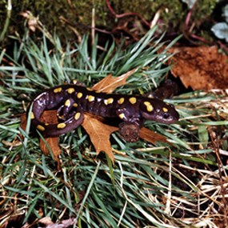
Spotted salamanders migrate to breeding pools in early spring.
Park staff and volunteers have monitored frogs and marsh birds since 1995 as part of a long term Marsh Monitoring Program (MMP). The MMP established by Bird Studies Canada and Environment Canada in 1994 is a bi-national, long term monitoring program that coordinates the skills, interests, and stewardship of hundreds of citizens across the Great Lakes Basin to help understand, monitor, and conserve the region's wetlands and their amphibian and bird inhabitants. The program receives support from Environment Canada, U.S. Great Lakes Protection Fund, U.S. Environmental Protection Fund, and Great Lakes 2000 Cleanup Fund.
The MMP has been monitoring trends in marsh birds and calling amphibians using data provided by more than 600 volunteer participants. Recent population trends for certain Great Lakes marsh birds appear to be emerging. Pied-billed Grebe and Common Moorhen, which require more “pristine” wetland conditions appear to be declining across the Great Lakes basin, while wetland generalist species commonly found along wetland edges (e.g., common yellowthroat, yellow warbler) are increasing. These results suggest habitat fragmentation and degradation are occurring throughout the region. MMP data also showed that most Great Lakes frog and toad species are declining, which further highlights the need for wetland conservation and restoration.

