Biscayne National Park

Established in 1980

History
A Tequesta man free-dives for conch from a dugout canoe, a Bahamian woman watches the sunset across a tidal creek, a ship grinds against a knife-edged reef while the wind howls, and wealthy industrialists gather under a shady palm to toss horseshoes. The parade of human history in the park spans 10,000 years.
Though the park was established for its natural history, signs are everywhere of people and the many ways they used these lands and waters. Islands reveal evidence of use by native peoples. Underwater, shipwrecks rest as silent witnesses to violent moments in time, each holding the promise of teaching us about our collective past. Pull up a rocking chair on the front porch of the Dante Fascell Visitor Center and you just might hear the story of how the park was established from one of the people that actually made it happen.
Biscayne's human history begins over 10,000 years ago with the migration of Paleo-Indians down the Florida peninsula. Physical evidence such as the campsite at the Old Cutler fossil site are well documented along the bay shoreline. When sea levels were very low during the ice age, the Florida peninsula was probably twice as wide as it is today, with most of that additional landmass being on the state's west coast. The area of what is today Biscayne Bay was probably a broad, dry savannah. This large, open expanse likely served as a place for nomadic peoples to hunt for mammoths, mastodons and other animals of the period.
As the ice age ended and waters began to rise, the bay filled in. For several thousand years after the time of the Paleo-Indians (now referred to as the Archaic Period), there is little physical evidence of native peoples in the Biscayne area, but that may be because evidence of these sites is now submerged. Many archaeologists believe there is much to learn about the area's earliest native peoples at the bottom of Biscayne Bay.
2500 years ago, the people in this area (now referred to as the Glades culture) had become less nomadic and more settled. Piles of discarded conch and whelk shells began to grow, and these shell middens offer archaeologists opportunities to learn about these people.
As populations grew and settlements split from one another, smaller, more distinct cultures developed. They created pottery and established trade networks. The people from this time period in southeast Florida are today known as the Tequesta.
Unlike many of the groups of people in other parts of the United States, and even in other parts of Florida, who began to rely heavily on corn and other crops, the Tequesta took advantage of the bounty of the sea. Having to spend less time working crops meant that there was more time for things like art and religion, and complex social structures developed. At the mouth of the Miami River, a village developed, and nearby a still-not-well-understood feature now called the Miami Circle was constructed.
The arrival of European explorers to the area in the 16th century was the beginning of the end for Florida's native peoples. Diseases like smallpox and measles swept through native populations in epidemic proportions. By the mid-1700s, virtually all of the area's indigenous people had been wiped out.
Around this time, Creeks from neighboring Georgia and Alabama began to expand into what is today Florida, eventually giving rise to tribes like the Seminole and Miccosukee.
Much of southeast Florida's native human heritage is now beneath the roads and buildings of Miami, Fort Lauderdale and surrounding communities. Large protected natural areas like Biscayne National Park may be the last, best chance for gaining a fuller understanding of the area's prehistory.
Coral Reefs
Park visitors may experience a kaleidoscope of colors and frenetic movements. Blue neon gobies and yellow striped porkfish punctuate a background of golden-brown elkhorn corals and swaying purple sea fans. A loggerhead sea turtle takes a breath at the surface as a young nurse shark settles to the bottom.
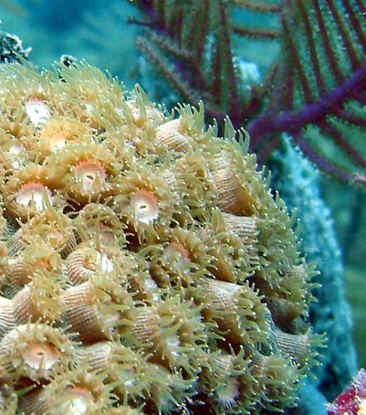
Corals extend tentacles to trap food particles. (NPS image by A. Bourque)Tiny coral animals, called polyps, obtain calcium from seawater and use it to build cup-like external skeletons around themselves. Generations of polyps create fantastic colonies that appear in the shapes of flowers, mountains or elk antlers. Colonies of different coral species create the living fortresses we call reefs.
Other reef dwellers include sea whips, sea fans and other soft corals that sway in the current and give the whole reef the appearance of movement. Bright sponges filter small plants and animals from the water. Christmas tree worms burrow into stony coral skeletons, adding tufts of red, orange and purple to the grooved surfaces of brain corals. Algae and other plants are important food sources for fish, shrimp, crabs and a myriad of other animals.

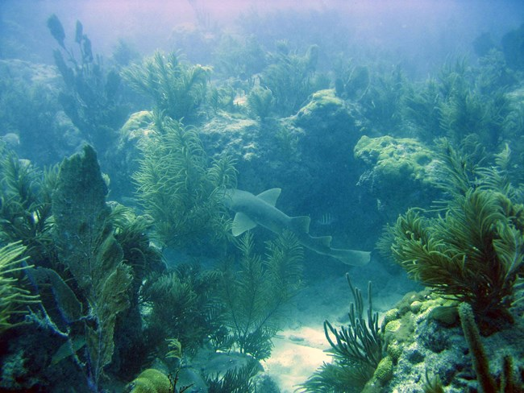
Nurse shark glides through a coral reef. (NPS image by A. Bourque)Like a bustling city, the reef is active day and night. Polyps on the soft corals withdraw as hard coral polyps emerge for a night of feeding. Parrotfish and wrasses wrap up in mucous sleeping bags, as octopi and squirrelfish become active. This "shift change" ensures that the reef's plentiful food supply is utilized around the clock.

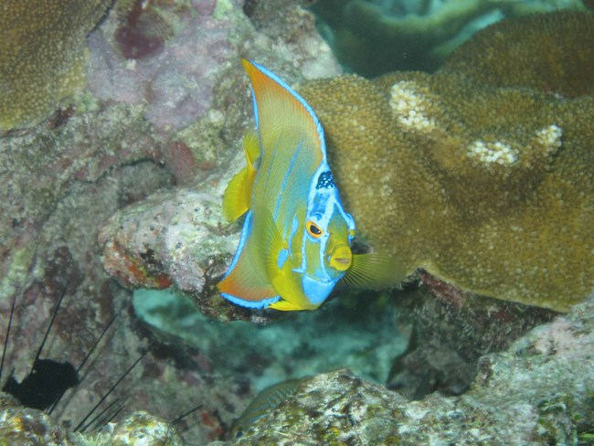
Queen angelfish (NPS image by A. Bourque).
For many, it is the fish that give reefs their magical qualities. The park is home to an incredible array of over 500 species of reef fish. The diversity of colors, shapes, sizes and behaviors is amazing. Inch long damselfish nip at diver facemasks, attempting to chase them away from carefully tended algae gardens. A green moray hovers nearby, mouth agape, at the entrance to its lair. A variety of fish wait at a "cleaning station" where tiny gobies scour their bodies for parasites. A stoplight parrotfish chomps on coral, devouring algae, polyps and stone in bites. A 500 pound goliath grouper peers out from under a ledge. A pair of spotfin butterfly fish float effortlessly through the water.
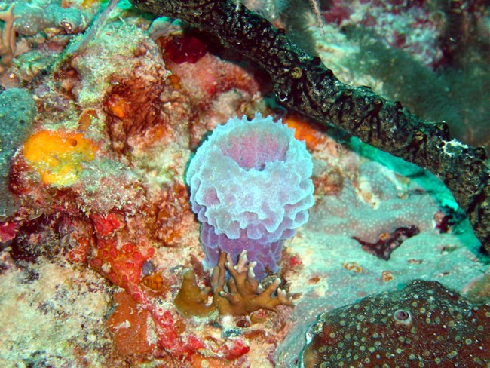
There are many unique sponges on coral reefs (NPS image by A. Bourque).
Coral reefs are among the most biologically diverse ecosystems on earth. Every crack and crevice seems to be occupied. Knowledge of reefs is constantly growing. This knowledge will be increasingly valuable as reefs around the world experience problems from pollution, overfishing, boat groundings, climate change, marine debris and disease.
The reefs of South Florida are accessible to millions of people who visit and live in the greater Miami area. For this reason, the reefs are also very vulnerable. When diving, snorkeling or boating, please remember the following tips:
- Tiny coral polyps are fragile and easily damaged by the slightest touch.
- Be aware of where your feet are placed and be careful not to cause damage with fins.
- Use proper nautical charts to avoid running aground.
- Use mooring buoys where available and ensure that anchors are not set in corals.
Simple things you can do to make a difference for the health of the reefs include avoiding anchoring on hardbottom, never tossing debris overboard and retrieving fishing gear and line that gets away from you.
Threats
Most coral reefs occur in shallow water near shore. As a result, they are particularly vulnerable to the effects of human activities, both through direct exploitation of reef resources, and through indirect impacts from adjacent human activities on land and in the coastal zone. Many of the human activities that degrade coral reefs are inextricably woven into the social, cultural, and economic fabric of regional coastal communities.
Coral reefs face many threats from local sources, including:
- Physical damage or destruction from coastal development, dredging, quarrying, destructive fishing practices and gear, boat anchors and groundings, and recreational misuse (touching or removing corals).
- Pollution that originates on land but finds its way into coastal waters. There are many types and sources of pollution from land-based activities, for example:
  - Sedimentation from coastal development, urban stormwater runoff, forestry, and agriculture
Sedimentation has been identified as a primary stressor for the existence and recovery of coral species and their habitats. Sediment deposited onto reefs can smother corals and interfere with their ability to feed, grow, and reproduce.
  - Nutrients (nitrogen and phosphorous) from agricultural and residential fertilizer use, sewage discharges (including wastewater treatment plants and septic systems), and animal waste
Nutrients are generally recognized as beneficial for marine ecosystems; however, coral reefs are adapted to low nutrient levels; so an excess of nutrients can lead to the growth of algae that blocks sunlight and consumes oxygen corals need for respiration. This often results in an imbalance affecting the entire ecosystem. Excess nutrients can also support growth of microorganisms, like bacteria and fungi, that can be pathogenic to corals.
  - Pathogens from inadequately treated sewage, stormwater, and runoff from livestock pens
Although rare, bacteria and parasites from fecal contamination can cause disease in corals, especially if they are stressed by other environmental conditions. Coral disease occurs in healthy ecosystems, but the input of pathogen-containing pollution can exacerbate the frequency and intensity of disease outbreaks.
  - Toxic substances, including metals, organic chemicals and pesticides found in industrial discharges, sunscreens, urban and agricultural runoff, mining activities, and runoff from landfills
Pesticides can affect coral reproduction, growth, and other physiological processes. Herbicides, in particular, can affect the symbiotic algae (plants). This can damage their partnership with coral and result in bleaching. Metals, such as mercury and lead, and organic chemicals, such as polychlorobiphenyls (PCBs), oxybenzone and dioxin, are suspected of affecting coral reproduction, growth rate, feeding, and defensive responses.
  - Trash and micro-plastics from improper disposal and stormwater runoff
Trash such as plastic bags, bottles, and discarded fishing gear (also called marine debris) that makes its way into the sea can snag on corals and block the sunlight needed for photosynthesis, or entangle and kill reef organisms and break or damage corals. Degraded plastics and microplastics (e.g., beads in soap) can be consumed by coral, fish, sea turtles, and other reef animals, blocking their digestive tracts and potentially introducing toxics.
- Overfishing can alter food-web structure and cause cascading effects, such as reducing the numbers of grazing fish that keep corals clean of algal overgrowth. Blast fishing (i.e., using explosives to kill fish) can cause physical damage to corals as well.
- Coral harvesting for the aquarium trade, jewelry, and curios can lead to over-harvesting of specific species, destruction of reef habitat, and reduced biodiversity.
The aggregate effects of these stressors can decrease resilience of the reef overall and increase susceptibility to disease and invasive species. Invasive species can create an imbalance in the biological checks and balances of a reef ecosystem.
Increased ocean temperatures and changing ocean chemistry are the greatest global threats to coral reef ecosystems. These threats are caused by warmer atmospheric temperatures and increasing levels of carbon dioxide in seawater.
As atmospheric temperatures rise, so do seawater temperatures. This warming causes corals to lose the microscopic algae that produce food that corals need, placing stress on the corals. Without this algae coral also lose their coloration—a condition known as coral bleaching— because the loss of algae reveals the white color of the calcium carbonate structure underlying the polyps. Severe or prolonged bleaching can kill coral colonies or leave them more vulnerable to other threats such as infectious disease.
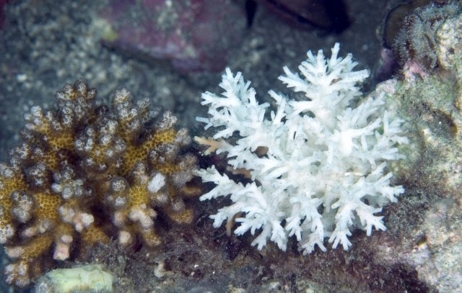
A healthy coral (left) and a coral that has experienced bleaching (right). Photo credit: Henry Wolcott/Marine PhotobankOther climate impacts, such as sea level rise, increased frequency and intensity of tropical storms, and altered ocean circulation patterns, can also affect coral reefs.
Ocean acidification refers to a change in ocean chemistry in response to the uptake of carbon dioxide from the atmosphere. The amount of carbon dioxide in the atmosphere is in equilibrium with that in seawater, so when atmospheric concentrations increase so do oceanic concentrations. Carbon dioxide entering seawater reacts to form carbonic acid, causing an increase in acidity.
Each year, the ocean absorbs about one-quarter of the carbon dioxide emitted from the burning of fossil fuels (oil, coal, and natural gas). Since the Industrial Revolution, ocean acidity has increased by about 30%, a rate that is more than 10 times what has previously occurred for millions of years. Further, ocean acidity levels are expected to increase by an additional 40% above present levels by the end of this century.
Increases in ocean acidity (measured by lower pH values) reduce the availability of dissolved salts and ions needed by corals to form the calcium carbonate structure. Consequently, coral growth and reef growth can be slowed, with some species affected more than others. If acidification becomes severe, coral skeletons can actually dissolve. On a local level, nutrient enrichment due to run-off from human activities on land can also cause increased acidity in coastal waters, exacerbating the effects of ocean acidification.

